Open ID tech Proposal:

Open ID is a decentralized means of authenticating users using a third party ID provider. URIs serve as user identifiers, each OpenID provider has their own methods for verifying the authentication of its users.

Example of OpenID URI: https://seanwhaley.pip.verisignlabs.com/

The Parties involved in and OpenID scheme are the user, ID provider where the user validates her or his identity and the Relying party or consumer site utilizing the openID service to provide authentication services.

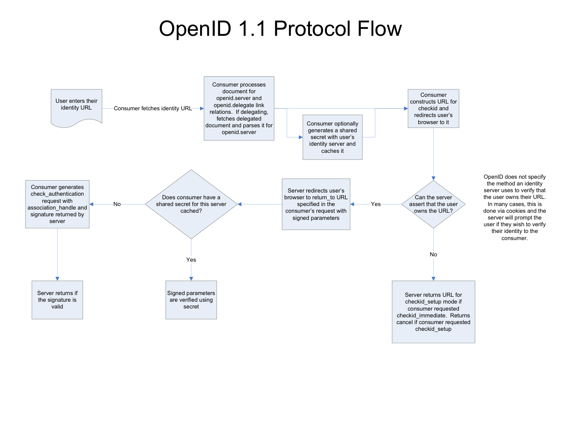

Figure 1 OpenID 1.1 protocol flow. <http://openid.net/pres/protocolflow-1.1.pnghttp://openid.net/pres/protocolflow-1.1.png>

The advantages of OpenID have been described by its creators at OpenID.net as “OpenID is a safe, faster and easier way to log into websites”.

OpenID facilitates safe logon to websites by allowing the user to enter their credentials in one place, on the OpenID site of their choosing. Through the use of tokens, the users password and other authentication factors remain between two parties, the OpenID provider and user, and are never shared with the consumer site. OpenID can be faster for users by utilizing demographic information used on the OpenID provider’s site to fill form information via OpenID attribute exchange. By maintaining user demographic information on one openID site, user maintenance of demographic data simpler for the end user, eliminating trips to multiple websites to update contact information. OpenID also brings benefits for the consumer site by offloading f some administration and support of password resets and logon issues to the OpenID providers. Consumer sites utilizing OpenID may have greater follow through with user registration given the simplicity and speed increases in use of OpenID.

What OpenID can do for Us

Our implementation of OpenID can utilize the authentication functions of OpenID for registration or just view events. Demographic information can be imported from the OpenID providers via OpenID attribute exchange to provide contact information and location.

Resources:

OpenID 1.1 protocol flow. http://openid.net/pres/protocolflow1.1.pnghttp://openid.net/pres/protocolflow-1.1.png

OpenID Attribute Exchange 1.0 - Draft 05. http://openid.net/specs/openid-attribute-exchange-1_0-05.html

Videos:

Its uses a mobile device but still relevant and short: <http://www.youtube.com/watch?v=utg0bRvaaQc>

Demonstrating user experience using OpenID:

<http://www.youtube.com/watch?v=-b1waIR44b4&hd=1>